## Predicting the age of abalone from physical measurements

MVP

**Overview:**

Predicting the age of abalone from physical measurements. The age of abalone is determined by cutting the shell through the cone, staining it, and counting the number of rings through a microscope -- a boring and time-consuming task. Other measurements, which are easier to obtain, are used to predict the age.

In this project, I will predict the age of the abalone through its physical measurements, which are represented by a 9 of feathers are:

|  |  |
| --- | --- |
| Sex | The abalone gender |
| Length | Longest shell measurement |
| Diameter | perpendicular to length |
| Height | with meat in shell |
| Whole weight | whole abalone |
| Shucked weight | weight of meat |
| Viscera weight | gut weight (after bleeding) |
| Shell weight | after being dried |
| Rings | +1.5 gives the age in years |

The analysis will be based on 4177 abalone measurements information

**Data Cleaning:**

* Check Null.
* Check duplicate
* EDA
* Convert Sex type to (0 , 1 , 2 ) [ 0 for infant ] , [ 1 for M ] , [ 2 for F ]

**Visualization:**

* **Scatter Plot**

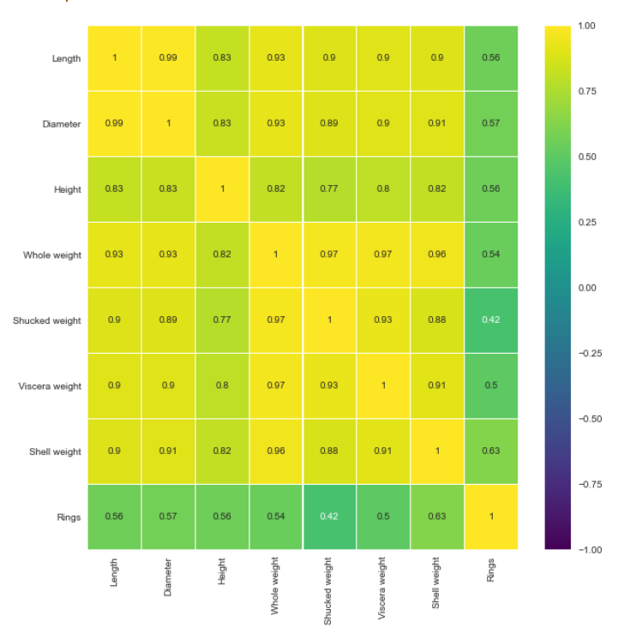

* We note that there is a strong correlation between age and most physical characteristics
* The physical characteristics share a strong correlation between them, which indicates the possibility of analyzing common characteristics for each age and gender
* **Pair Plot**
* 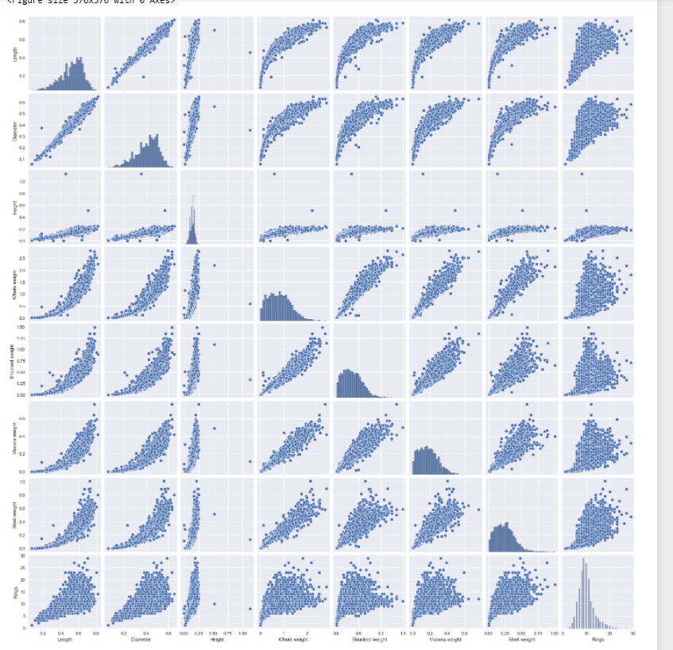
* 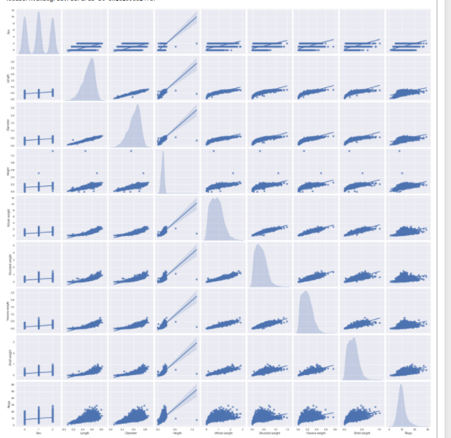 I found many linear relationships such as relationship between Length with Diameter and relationship between height with rings, and more other, that explain that I have a good data to predict the age from physical measurement feathers

This result indicates that lifespan can be largely predicted from shared traits, but it may not be the only factor helping to determine age accurately.

**Done by:**

Rawan Mohammad Balubaid

[Rawan-balubaid@hotmail.com](mailto:Rawan-balubaid@hotmail.com)

0540386411